【盛晨】
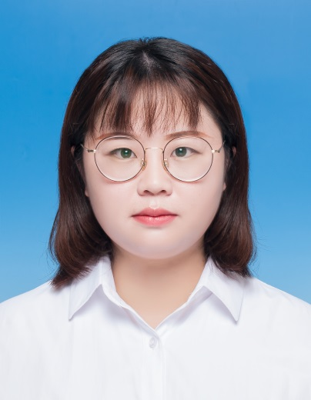
姓 名 | 盛晨
性 别 | 女
出生年月 | 1995年1月
学 位 | 博士研究生
专业 | 作物遗传育种
职 称 | 助教
E-mail | shengchen24@163.com

教师简介：博士毕业于华中农业大学，植物科学技术学院，作物遗传育种专业。研究方向为油料作物遗传育种。在Plant Physiology and Biochemistry、Frontiers in Plant Science等杂志发表多篇论文。

一、主讲课程
本科生：
研究生：

二、教育（）和工作经历
2024.01 — 至今 安庆师范大学 助教
2019.09 — 2023.06 华中农业大学 博士

三、教学科研项目情况
1.无
2.
3.
等等

四、发表论文情况
1. Sheng C, Song S, Zhou R, Li D, Gao Y, Cui X, Tang X, Zhang Y, Tu J, Zhang X, Wang L. QTL-Seq and Transcriptome analysis disclose major QTL and candidate genes controlling leaf size in sesame (Sesamum indicum L.). Front Plant Sci, 2021, 12:580846
2. Sheng C, Song S, Zhou W, Dossou SSK, Zhou R, Zhang Y, Li D, You J, Wang L. Integrating transcriptome and phytohormones analysis provided insights into plant height development in sesame. Plant Physiol Biochem, 2023, 198:107695
3. Song, Shengnan; Dossou, Senouwa Segla Koffi; Meng, Minghui; Sheng, Chen; Li, Huan; Zhou, Rong; Li, Donghua ; Xu, Pan; You, Jun; Wang, Linhai. Five improved sesame reference genomes and genome resequencing unveil the contribution of structural variants to genetic diversity and yield-related traits variation. Plant Biotechnol. J. 2023 June, DOI:10.1111/pbi.14092.
等等

五、获奖及荣誉情况（包括指导学生）
1. 无
2.
3.
等等
注：所有的字体、段落格式请按照上面的模板进行，切勿调整。

