【周鹏】
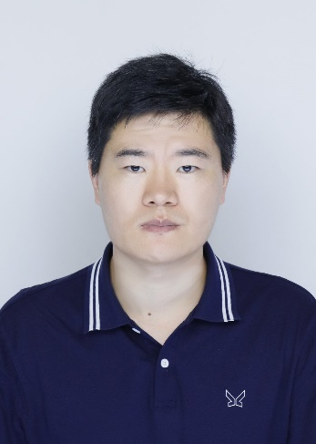
姓 名 | 周鹏
性 别 | 男
出生年月 | 1988.11
学 位 | 博士
专业 | 植物保护
职 称 | 讲师
E-mail | p.zhou@aqnu.edu.cn

周鹏，博士，讲师，硕士生导师。主要研究领域为农业害虫、害螨入侵生态学、生殖行为学、生活史策略以及寄生蜂生物防控生态学。在Journal of Economic Entomology, Systematic and Applied Acarology, BioControl, Biological Control等期刊上发表SCI论文10篇。

一、主讲课程
本科生：《生态学》《行为生态学》《污染生态学》《气象学》
研究生：《行为生态学》

二、教育和工作经历
2022.09 — 至今 安庆师范大学 讲师
2017.09 — 2022.11 新西兰梅西大学 博士

三、教学科研项目情况
1. 极端高温环境对截形叶螨个体适合度和种群动态影响的研究， Wxn202307，皖西南生物多样性研究和生态保护安徽省重点实验室开放基金，2023，在研，主持。

四、发表论文情况
1. Chen, C., He, X. Z., Zhou, P., & Wang, Q. (2024). Parasitoid–host interaction behaviors in relation to host stages in the Tamarixia triozae (Hymenoptera: Eulophidae)–Bactericera cockerelli (Hemiptera: Triozidae) system. Journal of Insect Science, 24(1), 15.
2. Chen, C., He, X. Z., Zhou, P., & Wang, Q. (2023). Life history and behavior of Tamarixia triozae parasitizing the tomato-potato psyllid, Bactericera cockerelli. Biological Control, 179, 105152.
3. Zhou, P., He, X. Z., Chen, C., & Wang, Q. (2022). Effect of age and density on dispersal probability and distance in Tetranychus ludeni Zacher. Zoosymposia, 22: 122-122.
4. Chen, C., He, X. Z., Zhou, P., & Wang, Q. (2022). Diets for Tamarixia triozae adults before releasing in augmentative biological control. BioControl, 67(3), 297–306.
5. Zhou, P., He, X. Z., Chen, C., & Wang, Q. (2021). Reproductive strategies that may facilitate invasion success: evidence from a spider mite. Journal of Economic Entomology, 114(2), 632-637.
6. Zhou, P., He, X. Z., Chen, C., & Wang, Q. (2021). Resource relocations in relation to dispersal in Tetranychus ludeni Zacher. Systematic and Applied Acarology, 26(11), 2018-2026.
7. Zhou, P., He, X. Z., Chen, C., & Wang, Q. (2020). No evidence for inbreeding depression and inbreeding avoidance in a haplodiploid mite Tetranychus ludeni Zacher. Systematic and Applied Acarology, 25(9), 1723-1728.
8. Chen, C., He, X. Z., Zhou, P., & Wang, Q. (2020). Tamarixia triozae, an important parasitoid of Bactericera cockerelli: circadian rhythms and their implications in pest management. BioControl, 65(5), 537-546.
9. Zhou, P., He, X. Z., & Wang, Q. (2018). Sons from virgin mothers produce more daughters in a haplodiploid mite. Systematic and Applied Acarology, 23(9), 1869-1878.
10. Zhou, P., Yang, H., Jin, D. C., He, X. Z., & Wang, Q. (2016). Sex-specific allometry of morphometric and reproductive traits in oriental fruit flies (Diptera: Tephritidae). Journal of Economic Entomology, 109(3), 1249-1253.

五、获奖及荣誉情况（包括指导学生）
1. 指导学生参加安庆师范大学生命科学学院第二届“原生造景生态缸制作大赛”获一等奖。

