【石新建】
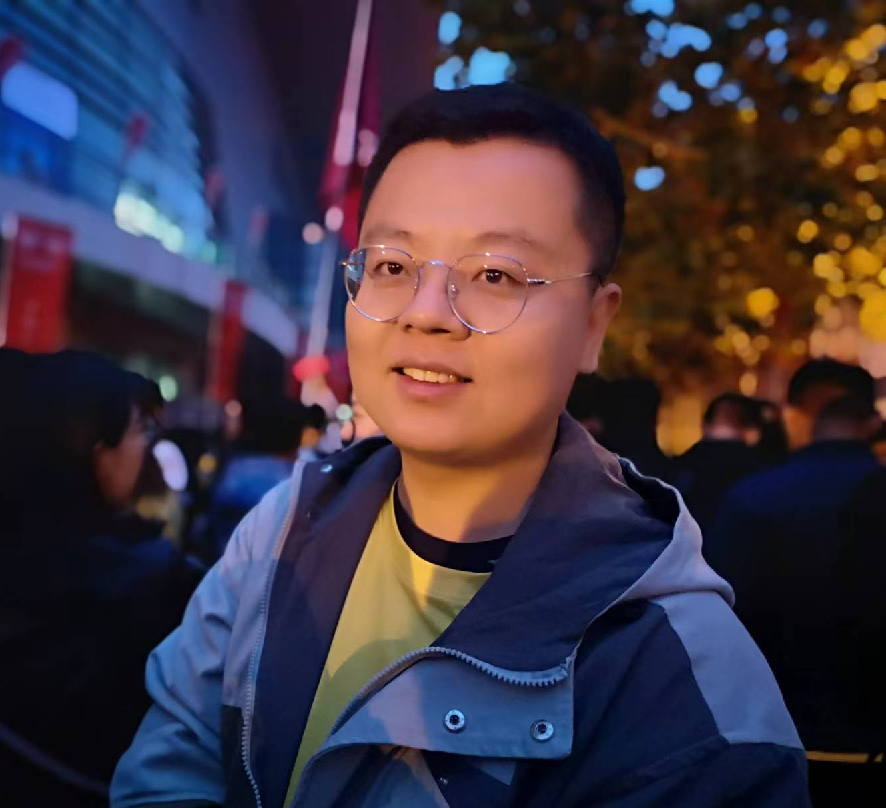
姓 名 | 石新建
性 别 | 男
出生年月 | 1989.01
学 位 | 博士
专业 | 植物学
职 称 | 讲师
E-mail | shixinjian01@qq.com

教师简介：石新建，男，汉族，1989年1月生，山东济宁人，中共党员，讲师。中国植物学会会员、中国生态学会会员。2022年博士毕业于南开大学植物学专业，获理学博士学位。主要从事植物-微生物互作、植物内生真菌生物防控领域的教学和科研工作。近年来参与国家自然科学基金项目 2 项。已发表科研论文 10 余篇。

一、主讲课程
本科生：植物学

二、教育和工作经历
2023.06 — 至今 安庆师范大学 讲师
2017.09 — 2022.12 南开大学 博士

三、教学科研项目情况
1. 内生真菌对禾草宿主和邻居非宿主植物抗病性的影响机制，国家自然科学基金委员会面上项目, 2023.01-2025.12, 在研，参加。
2. 内生真菌感染对宿主和非宿主禾草菌根依赖性的影响，国家自然科学基金委员会面上项目, 2019.01-2022.12, 结题，参加。
3. 新疆南疆荒漠植物抗逆基因的筛选和评价，兵团科技计划项目，2012.01-2015.12, 结题，参加。
四、发表论文情况
1. Shi X, Qin T, Chen J et al. Infection by endophytic Epichloë sibirica was associated with activation of defense hormone signal transduction pathways and enhanced pathogen resistance in the grass Achnatherum sibiricum. Phytopathology. 2022, 112:2310-2320.
2. Shi X, Qin T, Qu Y et al. Comparative omics analysis of endophyte-infected and endophyte-free Achnatherum sibiricum in response to pathogenic fungi. Biological Control. 2022, 175: 105040.
3. Shi X, Qin T, Liu H, Wu M et al. Endophytic fungi activated similar defense strategies of Achnatherum sibiricum host to different trophic types of pathogens. Frontiers in Microbiology. 2020, 11: 1607.
4. 石新建, 张靖歆, 秦天姿等. 内生真菌感染对宿主羽茅及邻生植物抗病性的影响. 植物生态学报. 2021, 45(8): 860-869.
5. 石新建, 王彦芹, 李志军. 盐旱胁迫对花花柴种子萌发与幼苗生理生化特性的影响. 草业科学. 2017, 34(9): 1855-1862.
6. Zhang, Junzhen, Yu, Xinhe, Qu, Yaobing, Shi, Xinjian et al. The decreasing trend of the competitive advantage of endophyte-infected Achnatherum sibiricum over endophyte-free plants under high nitrogen conditions was reversed by pathogenic fungi inoculation. Plant and Soil. 2023, 493(1): 427-439.
7. Hao, Guang, Yang, Nan, Liu, Yulin, Shi Xinjian et al. The relative importance of drought stress and neighbor richness on plant–plant interactions shifts over a short time. Science of the Total Environment. 2023, 892:164534.
8. Qu, Yaobing, Qin, Tianzi, Shi, Xinjian et al. The effects of Epichloë endophytes on the growth and competitiveness of Achnatherum sibiricum are mediated by soil microbe diversity. Journal of Plant Ecology. 2023, 16(1): rtac028.
9. Zhang, Junzhen, Deng, Yongkang, Ge, Xiaoyu, Shi, Xinjian et al. The beneficial effect of Epichloë endophytes on the growth of host grasses was affected by arbuscular mycorrhizal fungi, pathogenic fungi and nitrogen addition. Environmental and Experimental Botany. 2023, 201:104979.
10. Hao, Guang, Yang, Nan, Dong, Ke, Xu, Yujuan, Ding, Xinfeng, Shi, Xinjian et al. Land Degradation and Development. 2021, 32(10):3142-3153.
11. Liu, Hui, Chen, Jing, Qin, Tianzi, Shi, Xinjian et al. Removal of soil microbes alters interspecific competitiveness of Epichloë endophyte-infected over endophyte-free Leymus chinensis. Microorganisms. 2020, 8(2): 219.

